**CS401 Assignment #1 Spring 2022**

***Name: Abdul Rehman.***

***VU-ID: BC200403287.***

**Question:**

You are required to write an assembly language program to calculate the exponential value of the last two digits in your VUID. For example, if the VUID is mc020400456, then your code should calculate 56 that is equal to 15625 decimal and save it in memory.

Attach the screenshot of AFD debugger showing the final result in the memory.

Note: Your code should be able to calculate the exponential values of any set of coefficient and exponent values.

Hint: 56 =  = 15625.

**Solution:**

**My VU-ID: BC200403287.**

2nd Last digit is 8.

Last digit is 7.

**Assembly Language Program:**

[org 0x0100]

jmp start

r:dd 0

start

mov ebx,8

mov ecx,7

cmp ecx,0

jz stop_1

cmp ebx,0

jz stop_0

mov eax,1

L1:

jcxz stop_3

mul ebx

loop L1

stop_0:

mov [r],eax

stop_1:

mov [r],eax

stop_3:

mov [r],eax

mov ax,0x4c00

int 0x21

**Screenshots:**

1. Calculate exponential value of 87 **(Last 2 digits of my VU-ID)**:

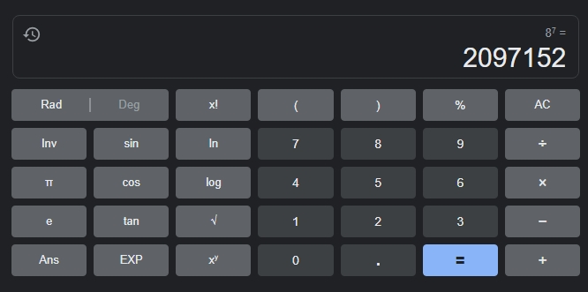

1. Convert Decimal value **(2097152)** to Hexadecimal **(200000)** value:

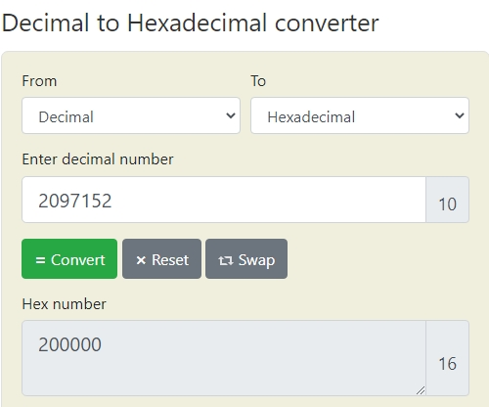

1. Full Screenshot of AFD Debugger:

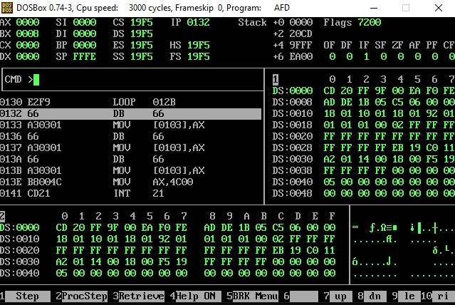

1. Screenshots of AFD Debugger with Final Value and Result in Memory:

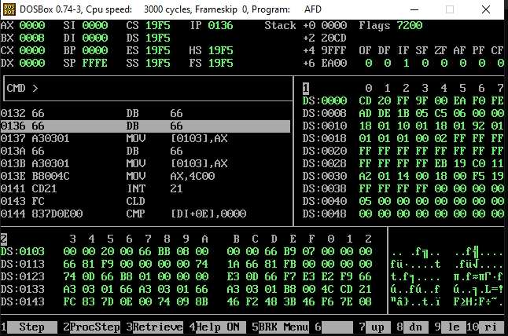

1. Terminated Program Screenshot:

